COMMAND LINE UTILITIES

T. Pavan Kumar

CB.SC.P2CYS24018

3)ipconfig:-

It displays the information about IPv6 address, IPv4 address, subnet mask and default gateway of all network interfaces of our device.

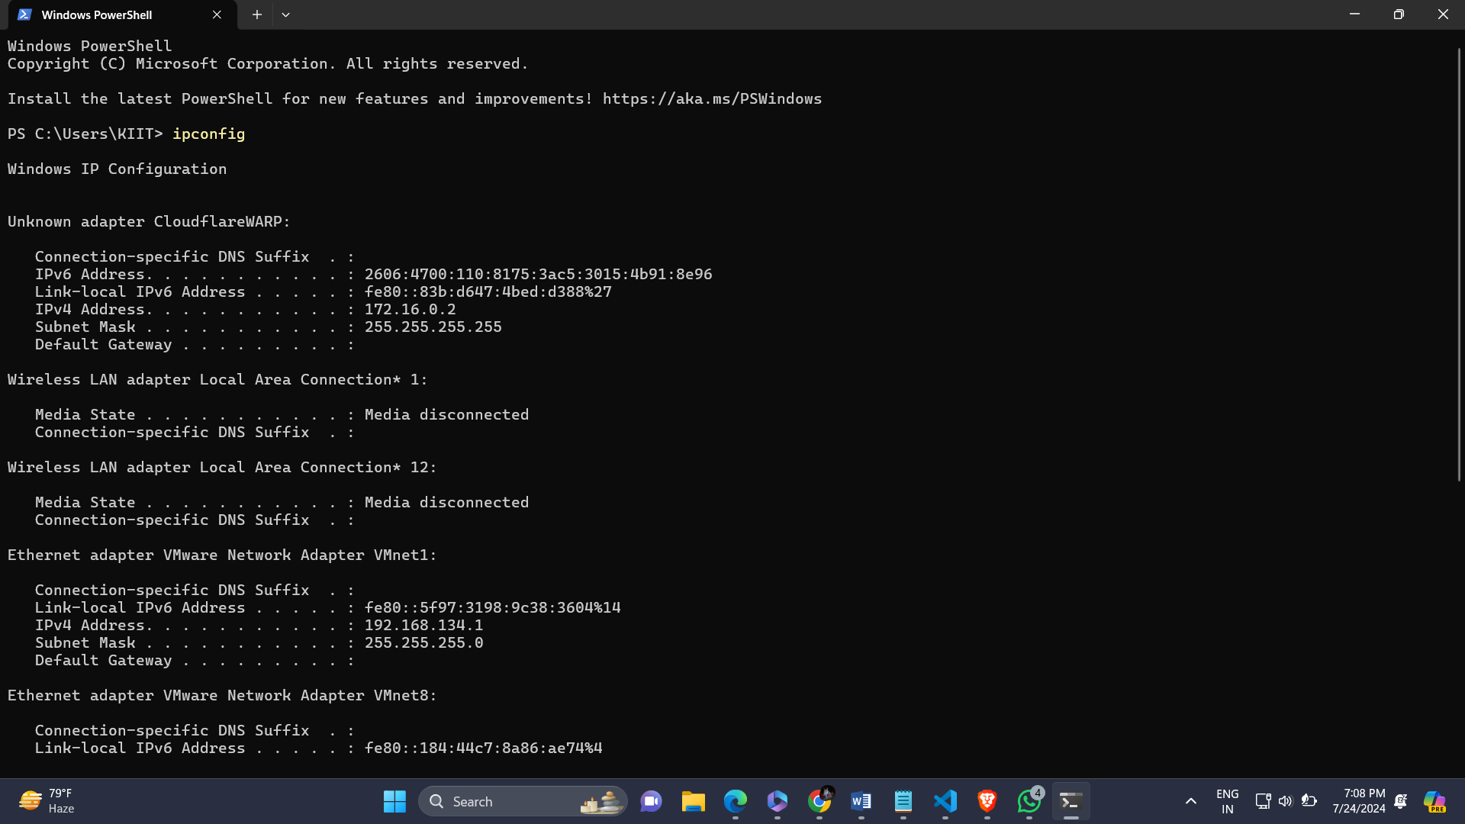

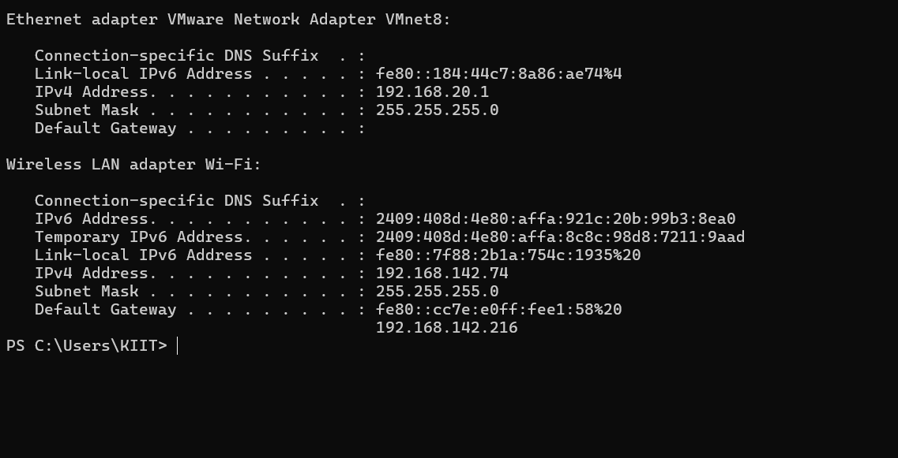

6)ipconfig /all:-

It display the Host Name.

It displays the information about MAC address, IPv6 address, IPv4 address, subnet mask, default gateway, DHCP server and DNS servers of all network interfaces of our device.

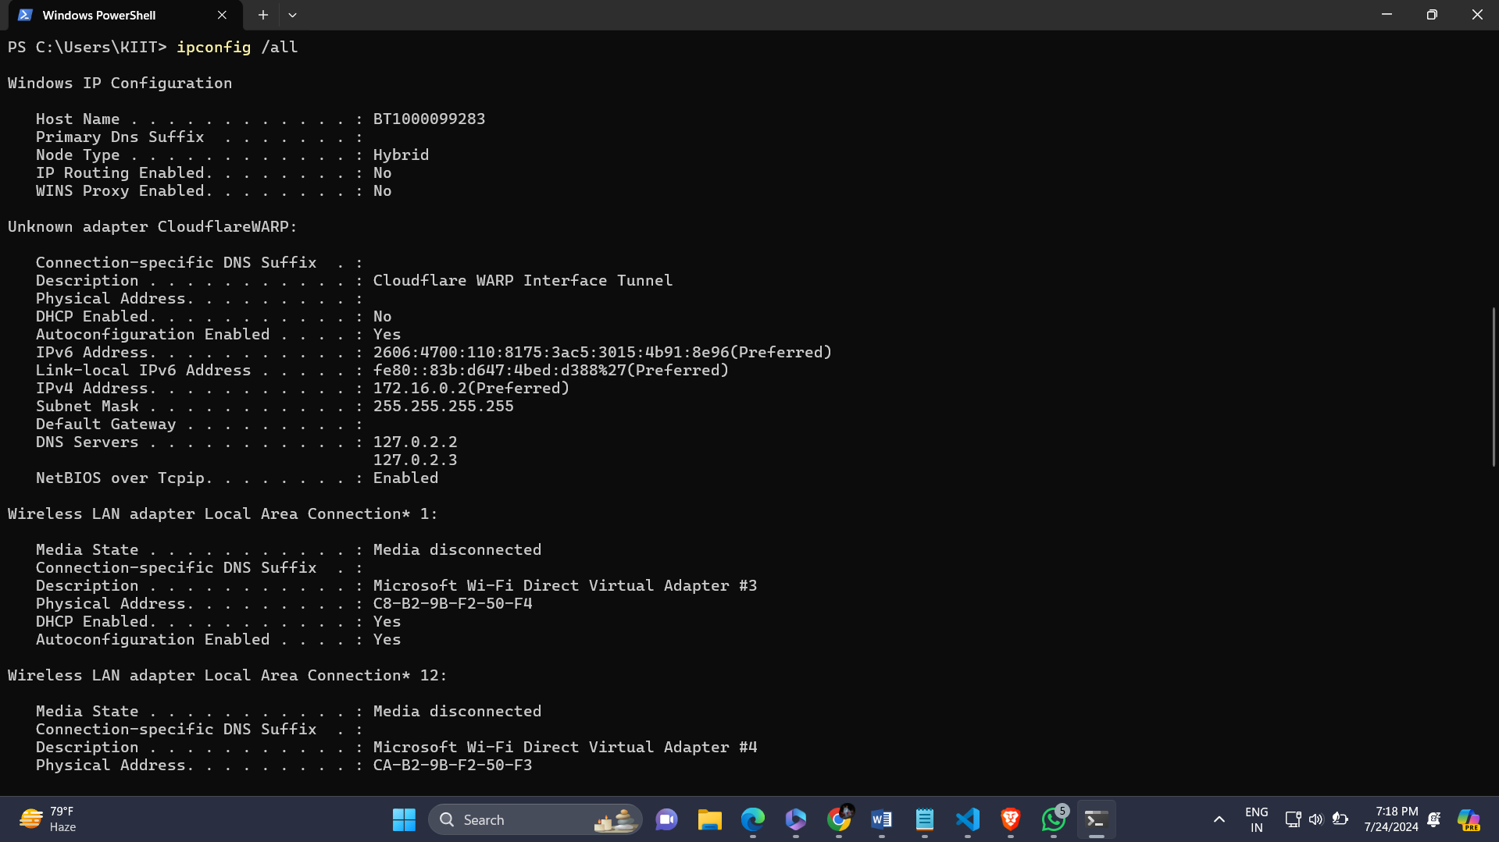

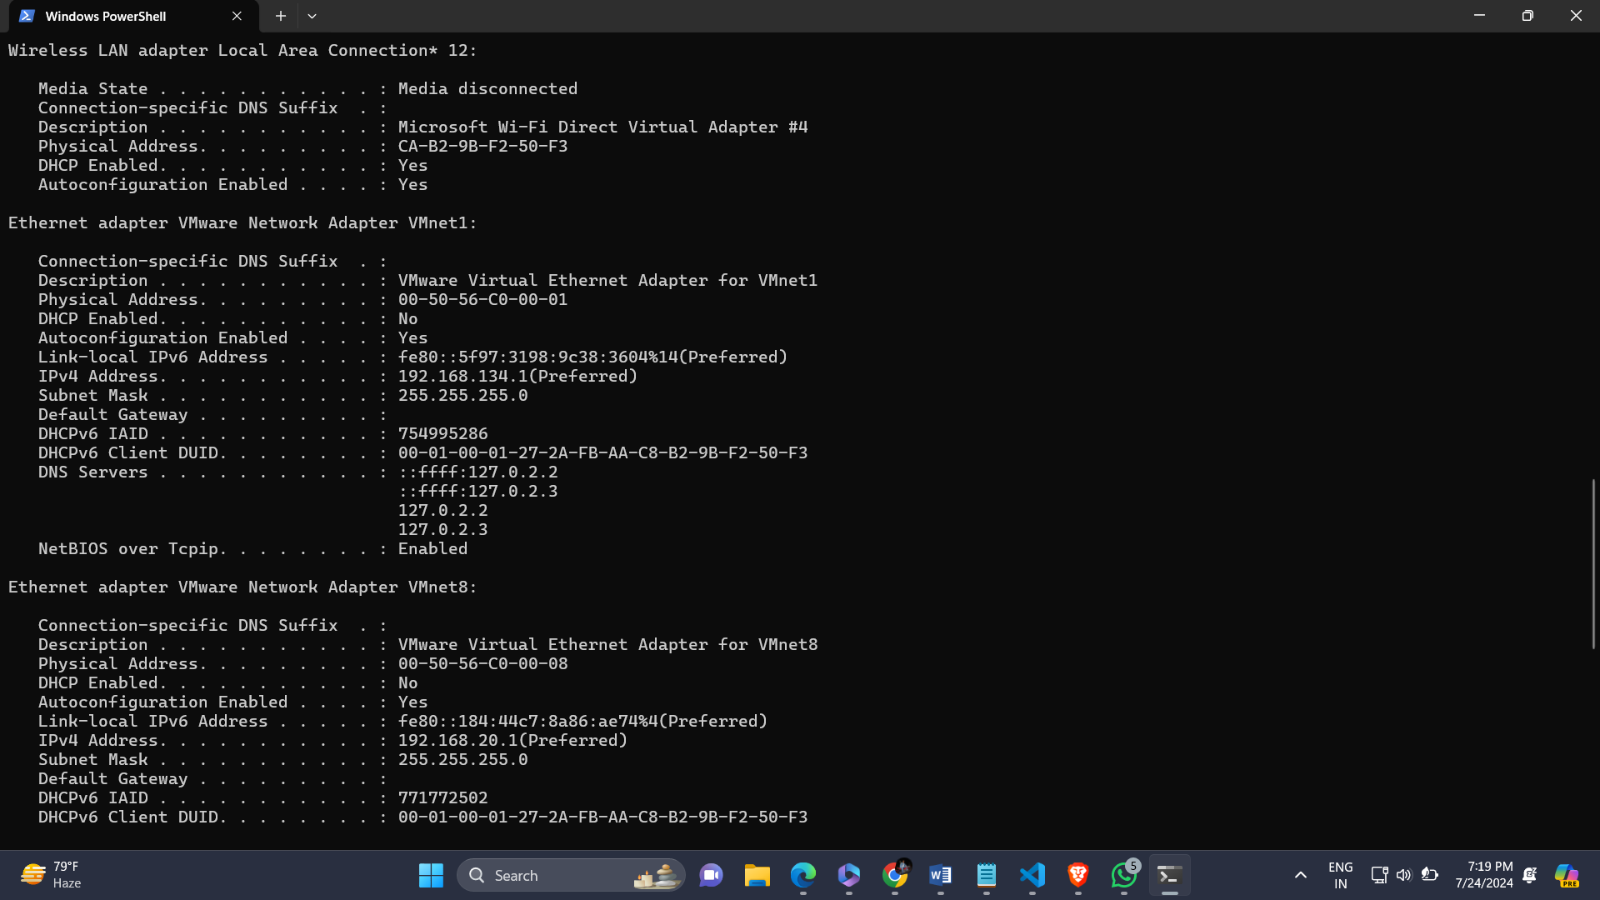

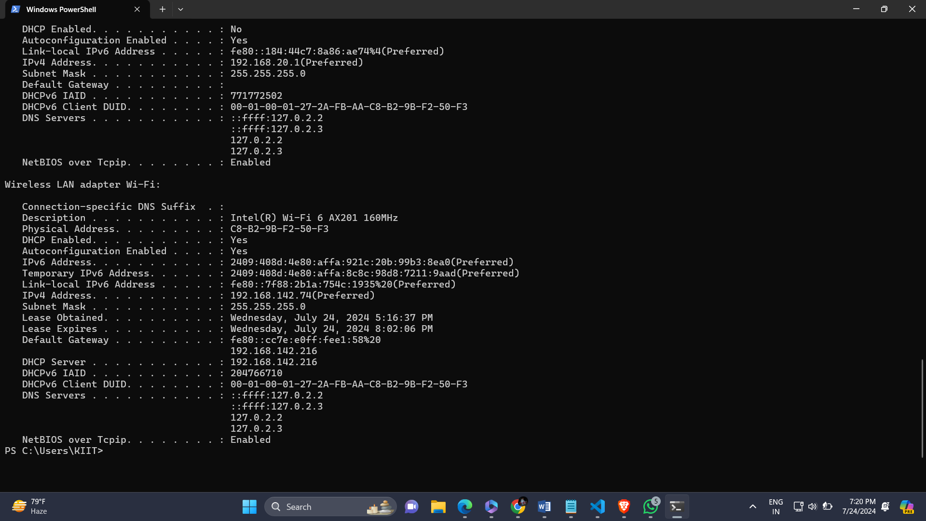

Ipconfig /renew:-

It requests a new IP address from the DHCP server for only Local Area Connection Adapter.

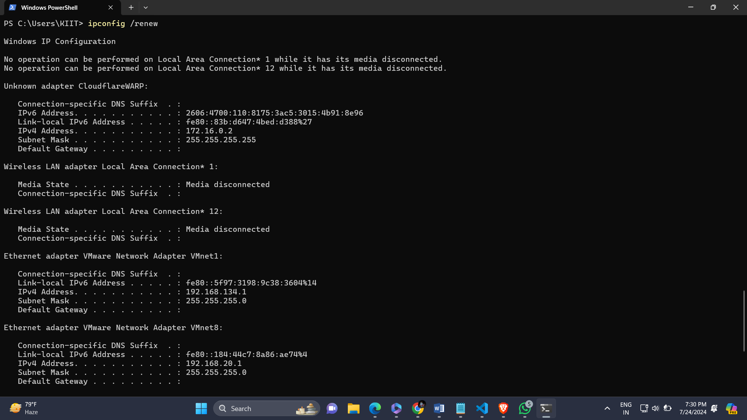

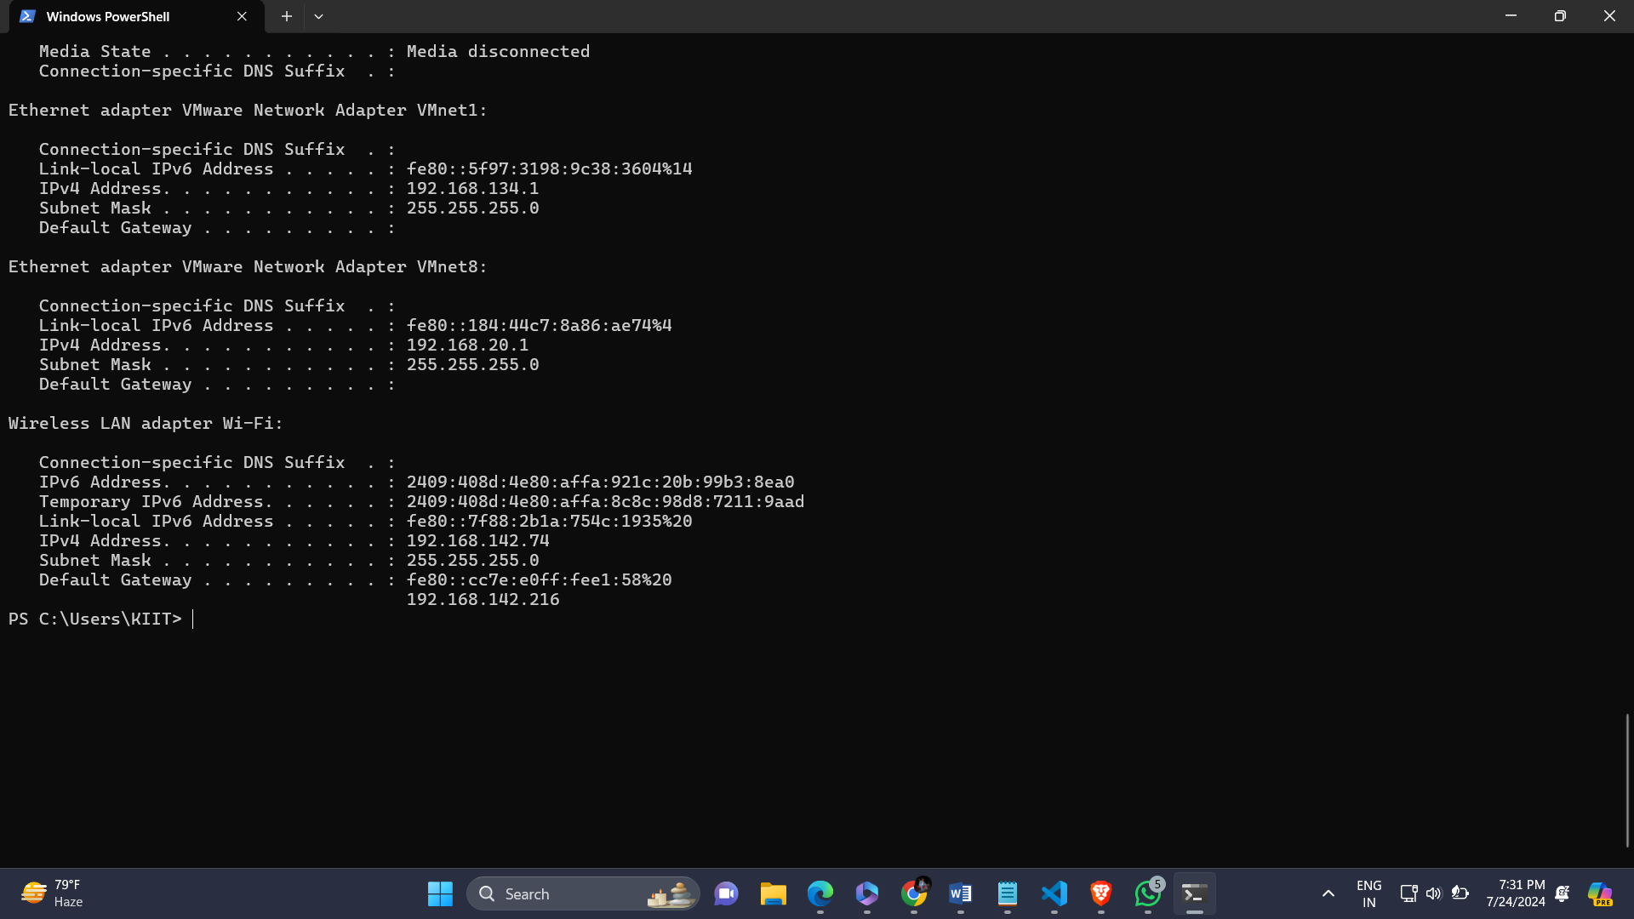

Ipconfig /release

It is used to disconnect from the current IP address assigned by DHCP server, clear network settings.

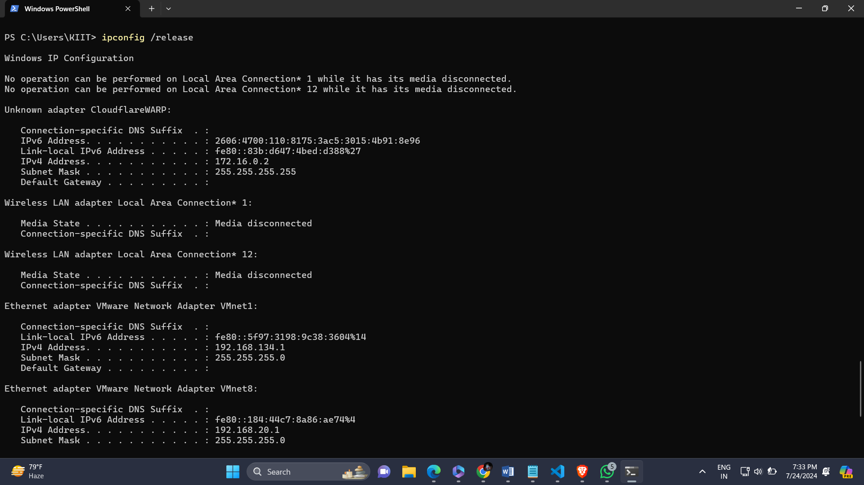

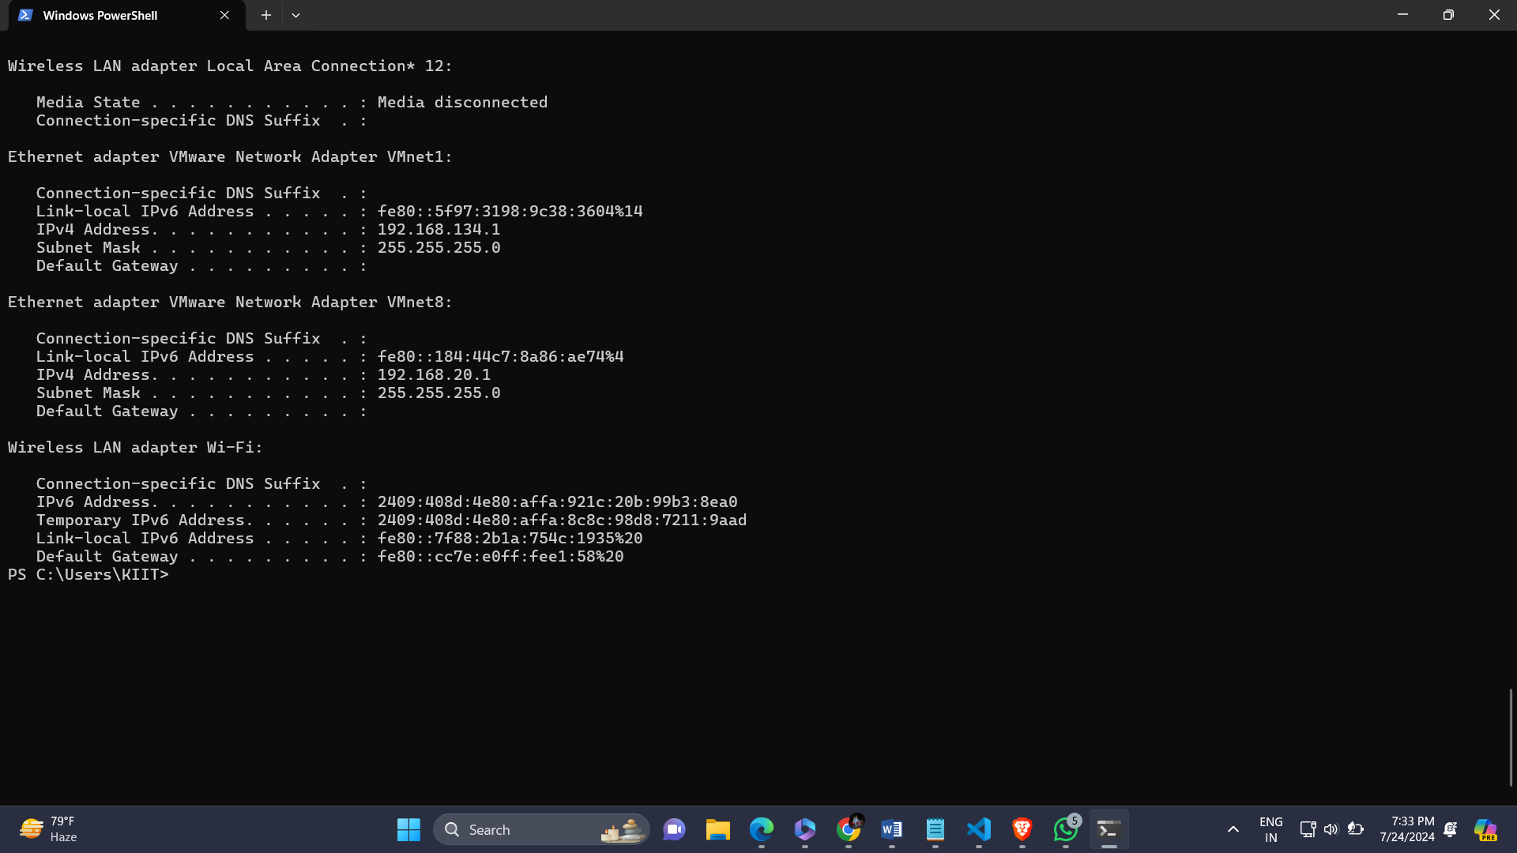

Ipconfig /flushdns

It clears DNS Resolver Cache, ensuring that the system fetches the latest DNS information from the DNS server.

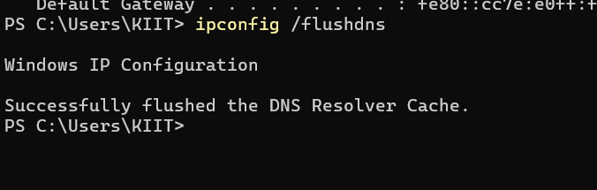

Ipconfig /displaydns

It displays all the DNS Resolver Cache from websites we visited.

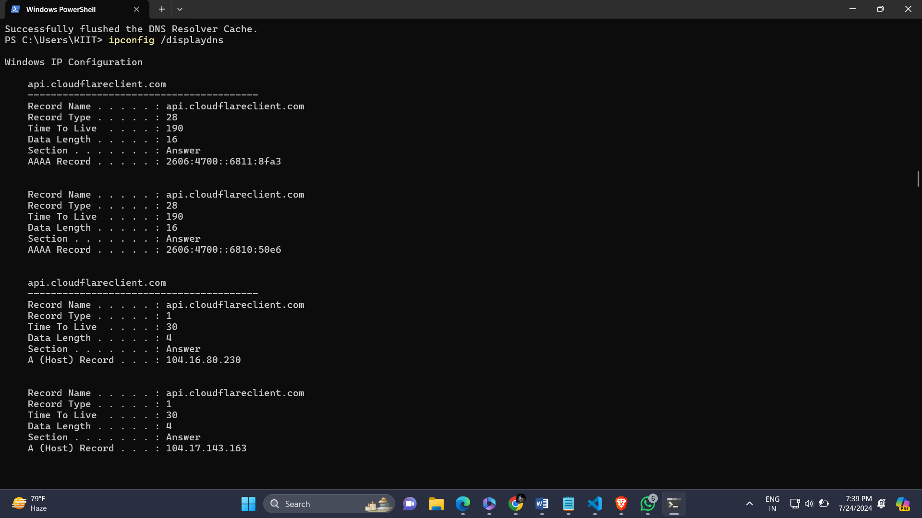

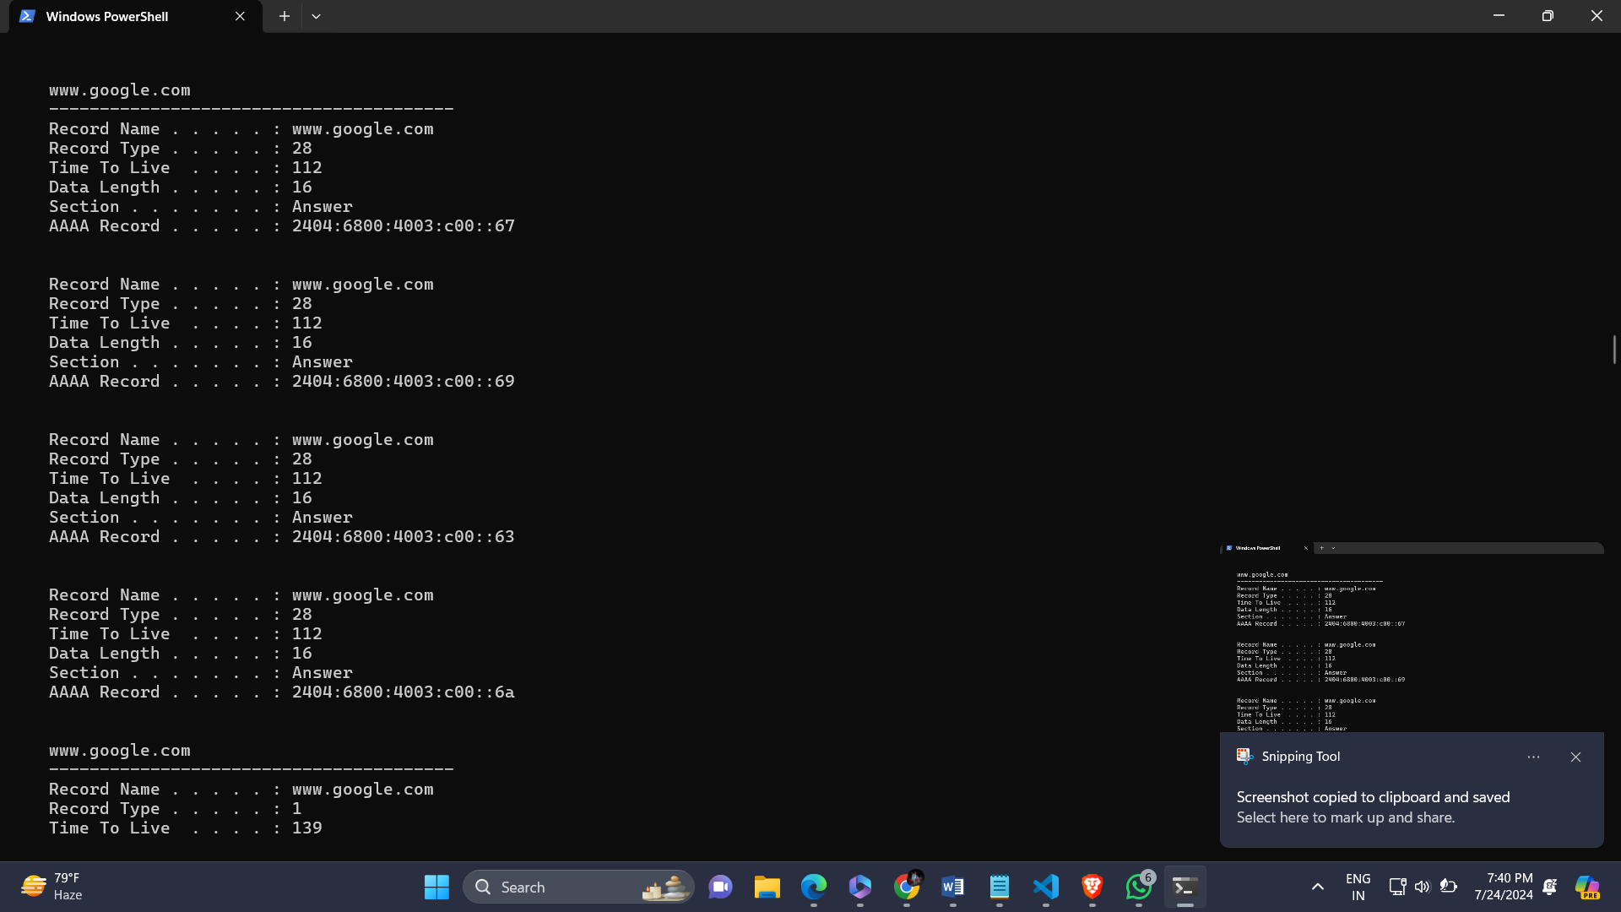

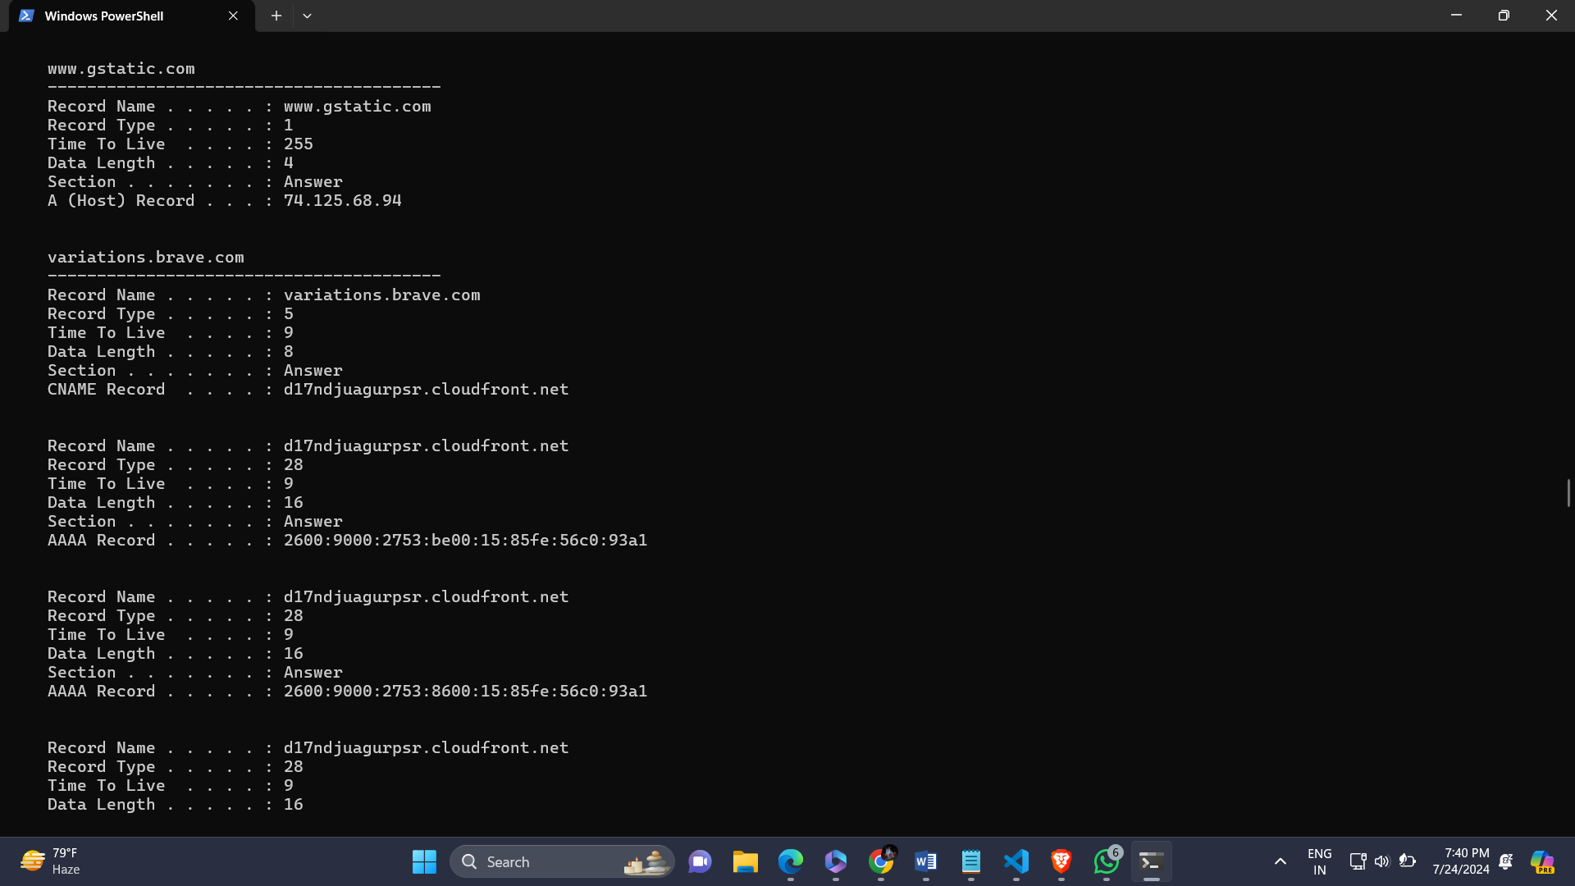

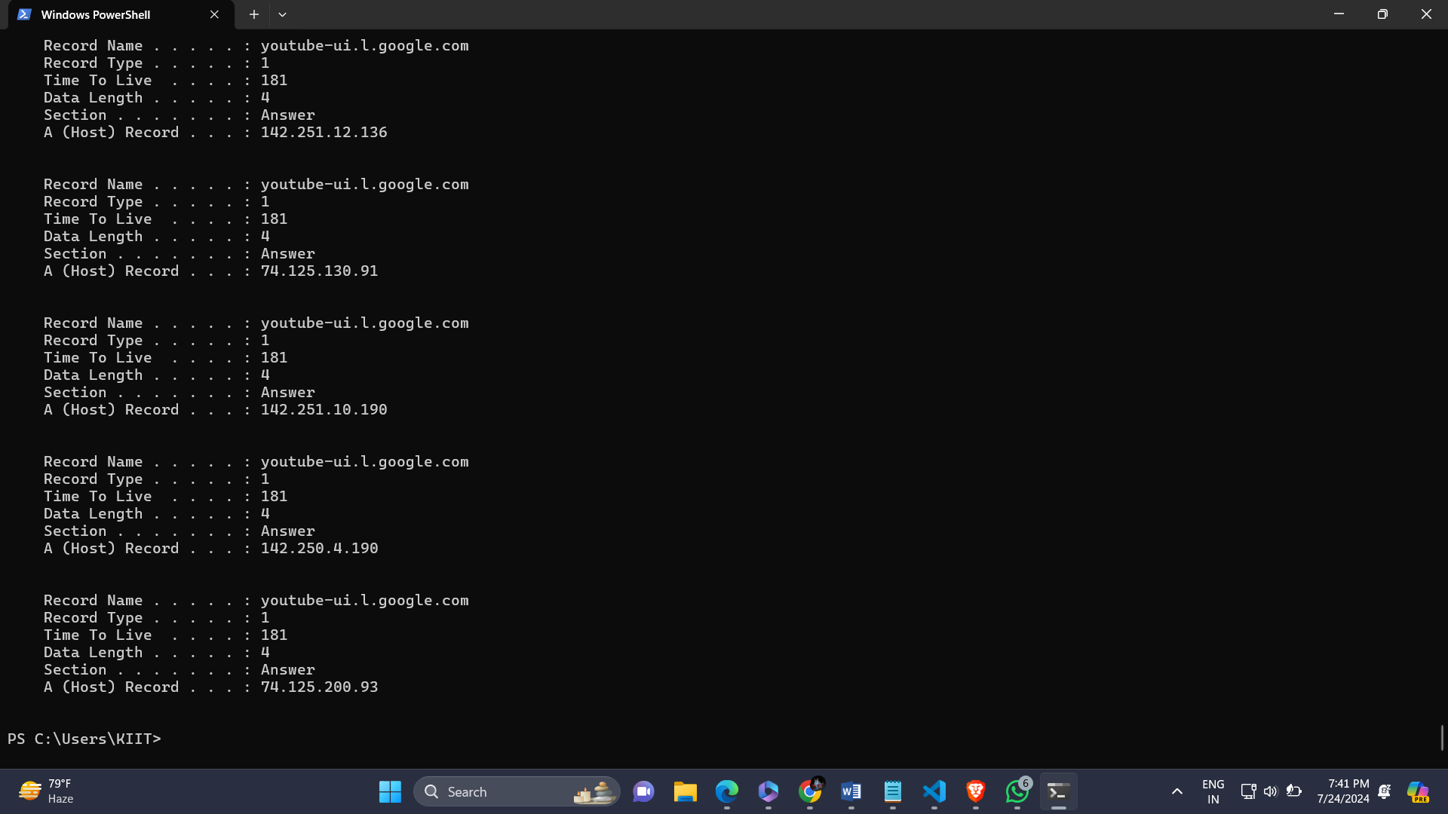

Ipconfig /registerdns

It is used to refresh and update the device DNS name registration in DNS server.

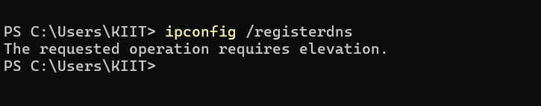

Ipconfig /showclassid adapter

It is used to display the DHCP class IDs for adapter.

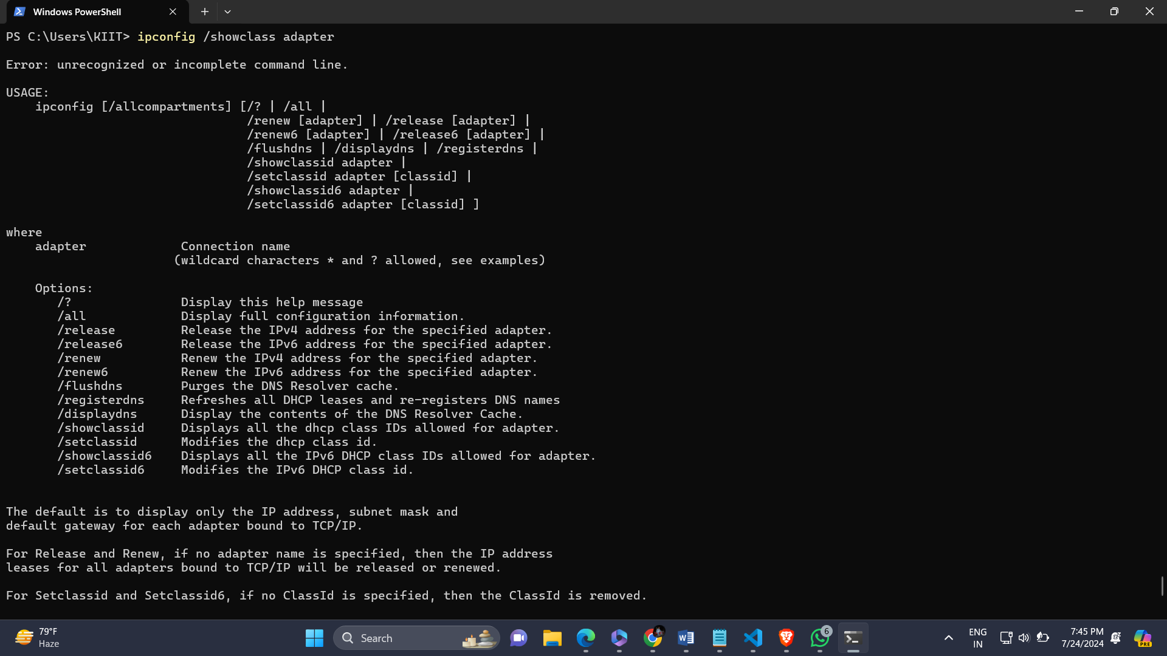

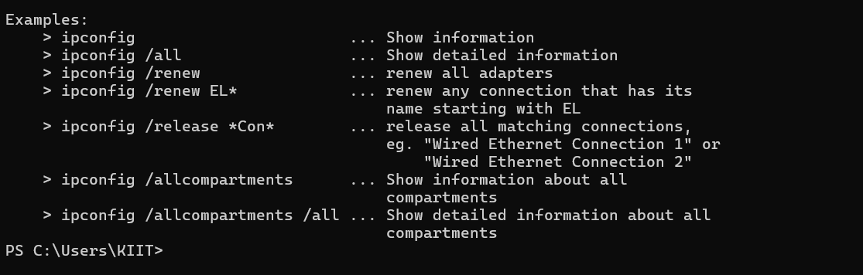

Ipconfig /setclassid adapter

It is used to Configures the DHCP class IDs for adapter.

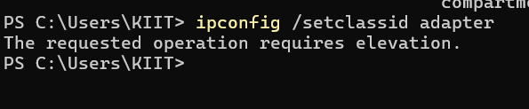

Ipconfig /?

It is used to display a list of all commands with their descriptions in “ipconfig” .

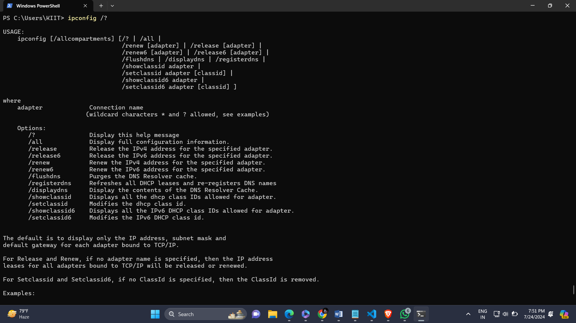

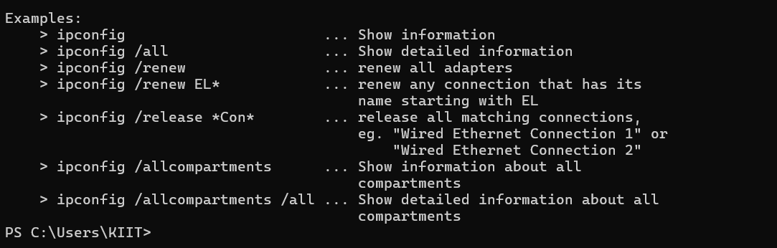

Ping

It is used to check the connection between our device and other device on network by sending small packets of data and measuring the response time.

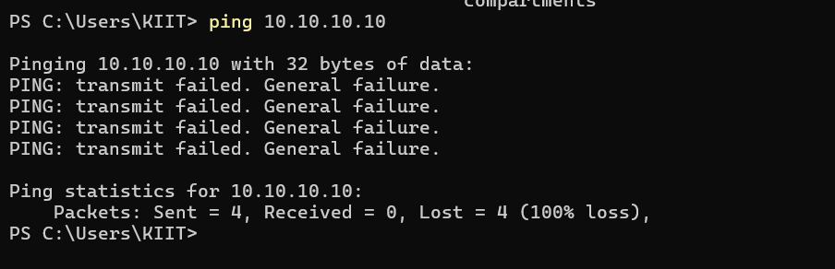

Ping –n count

It is used to set the no of echo requests to send . by default it sends 4 requests.

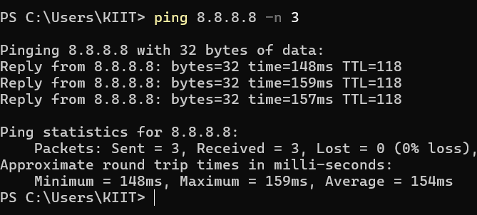

ping –w timeout

By specifying a timeout value when executing the ping command adjust the amount of time , in milliseconds so that it waits for each reply. Default timeout value is 4000(4 seconds).

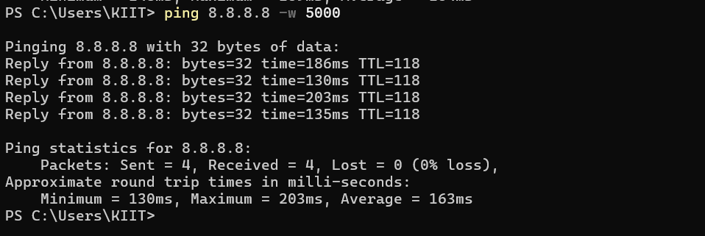

Ping –l size

It is used to set the echo request packet size in bytes.

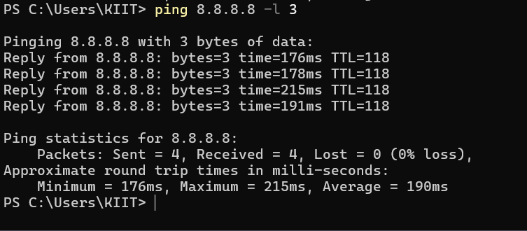

Ping –f

It sends ping requests to the IP address 8.8.8.8 with the “don’t Fragment “ flag set.(means packets must be transmitted without fragmentation).

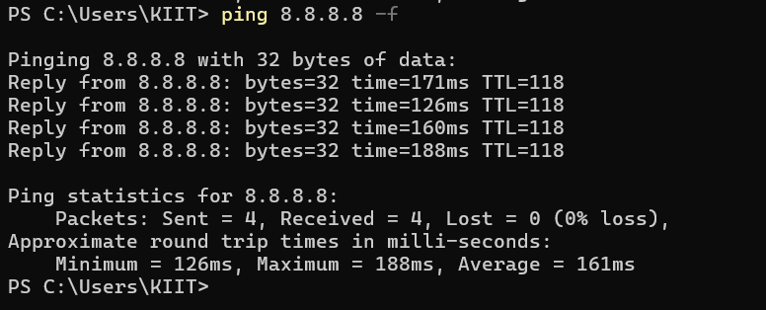

Tracert

It tracks the path taken by packets from our device to a destination IP address or hostname.

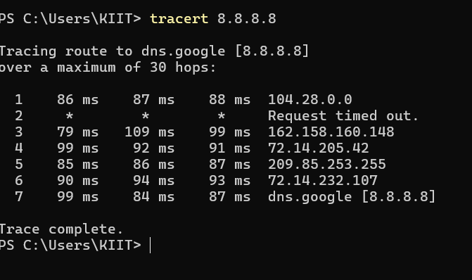

Nslookup

It is used to retrieve a domain’s information, including its IP addresss and

DNS record.

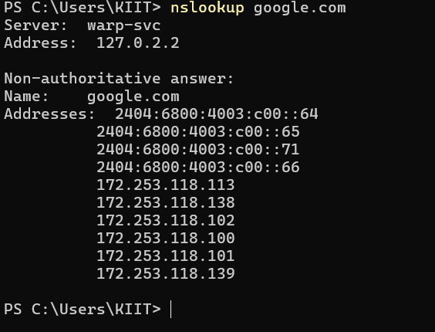

Nslookup –type =a

It is used to get the IP address for a given hostname or to to get a hostname for a given IP address.

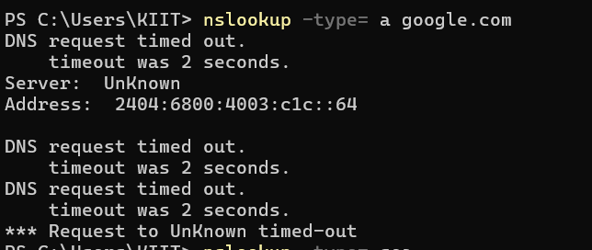

Nslookup –type =soa

It provides information about the primary DNS server for a domain and its administrative details.

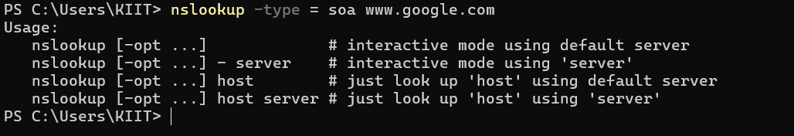

Netstat

It shows a list of active network connections , listening ports and network statistics.

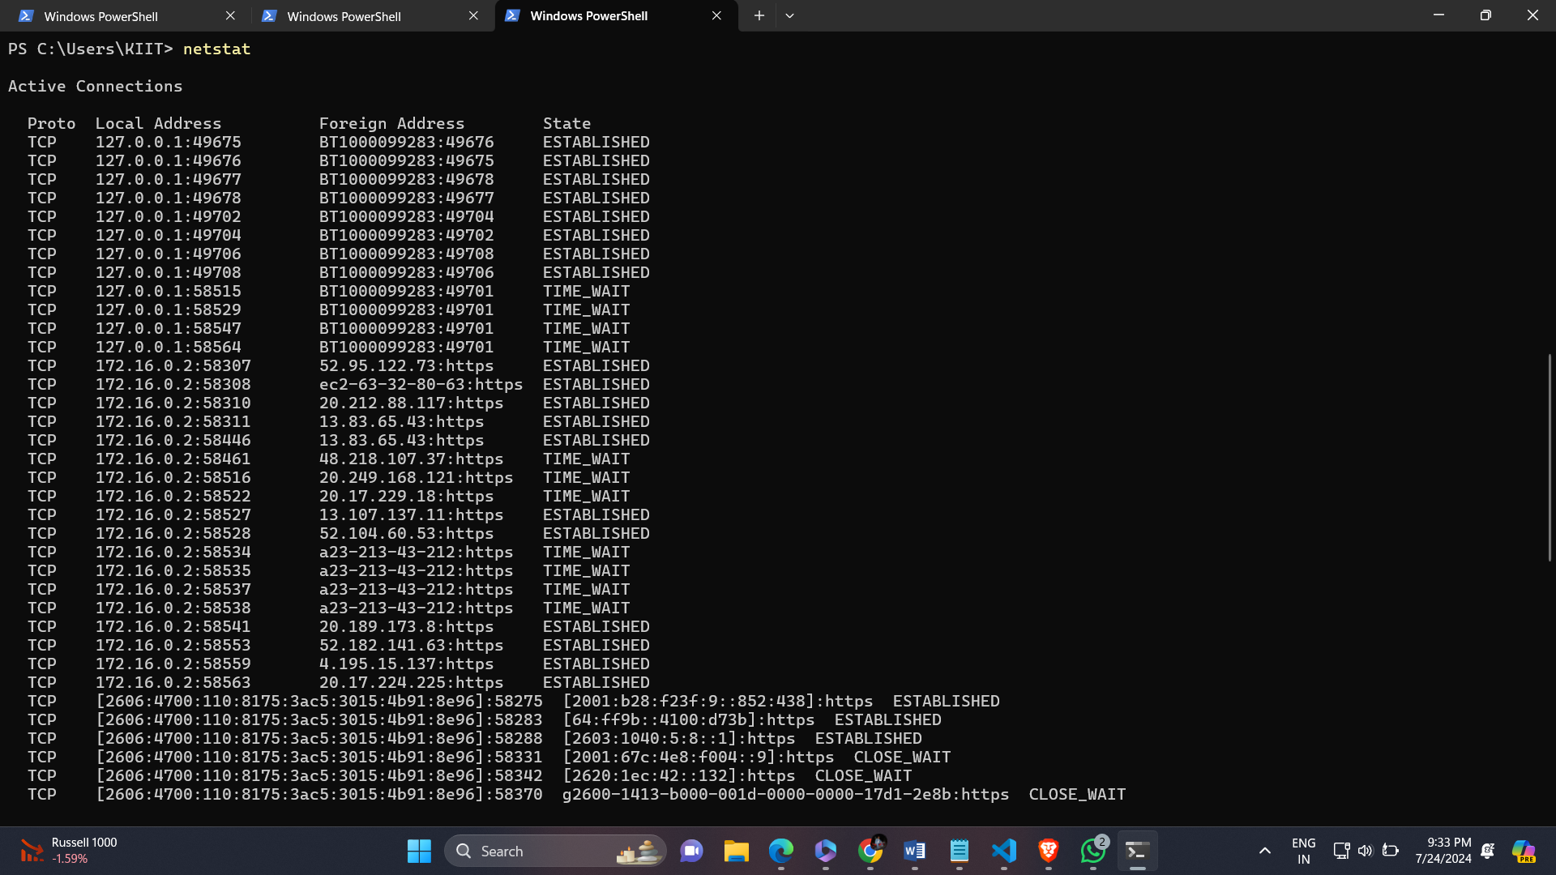

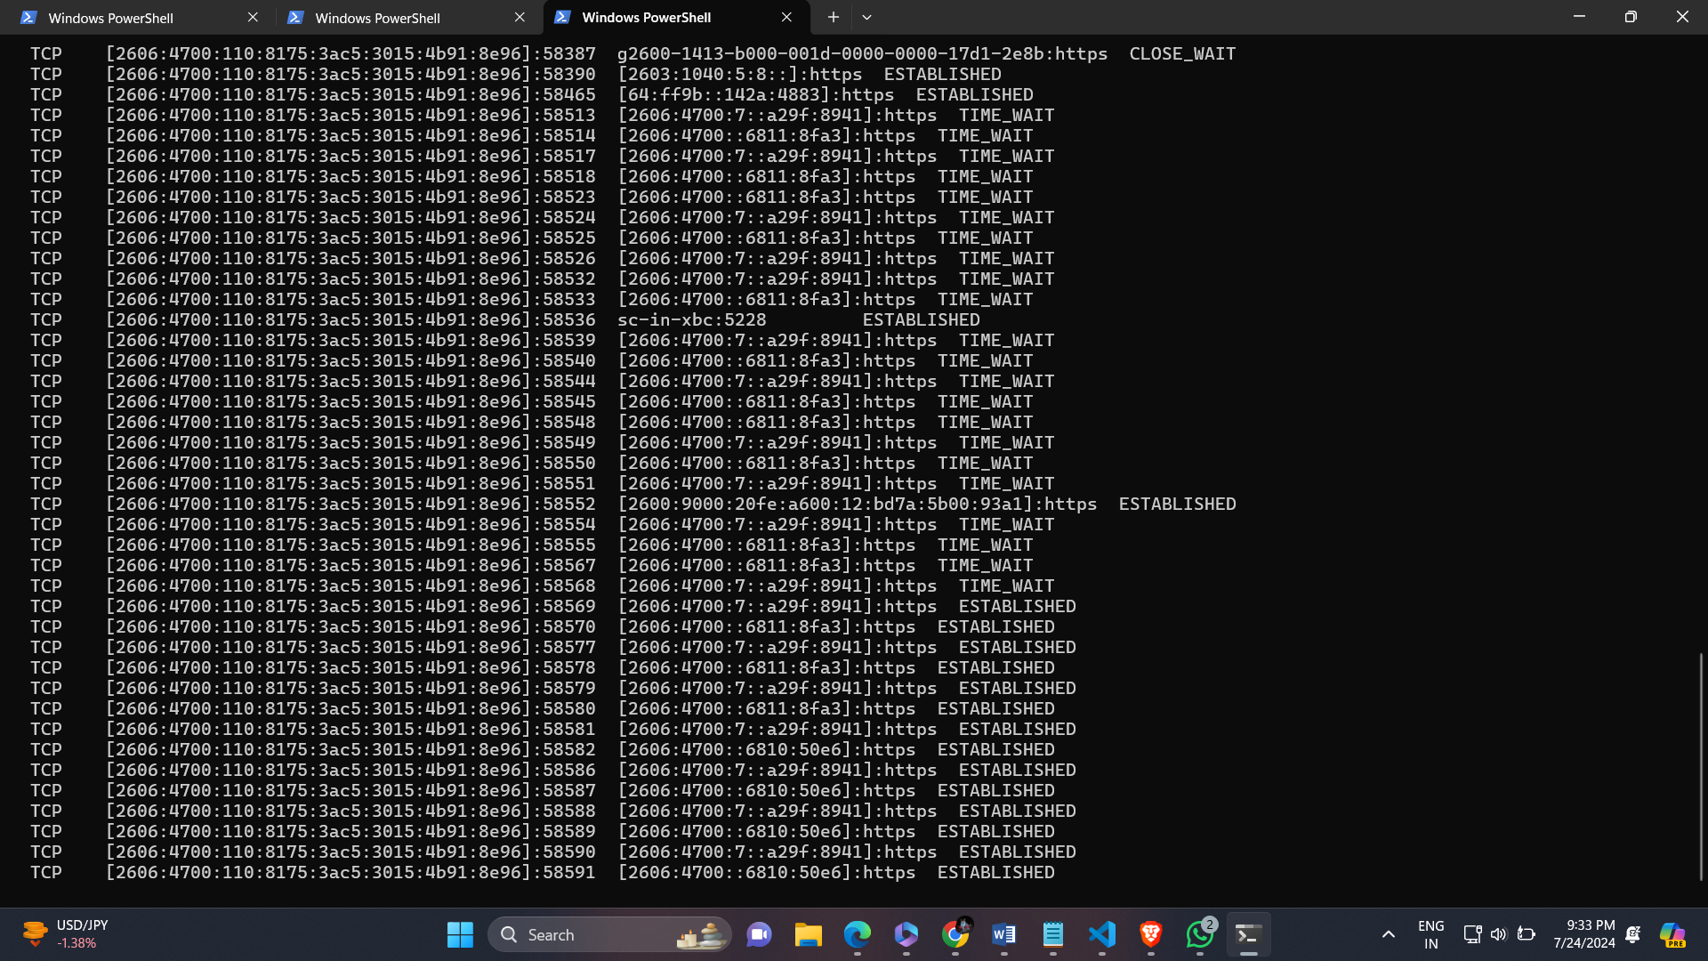

Netstat –a

It displays all active network connections and listening ports of both TCP and UDP.

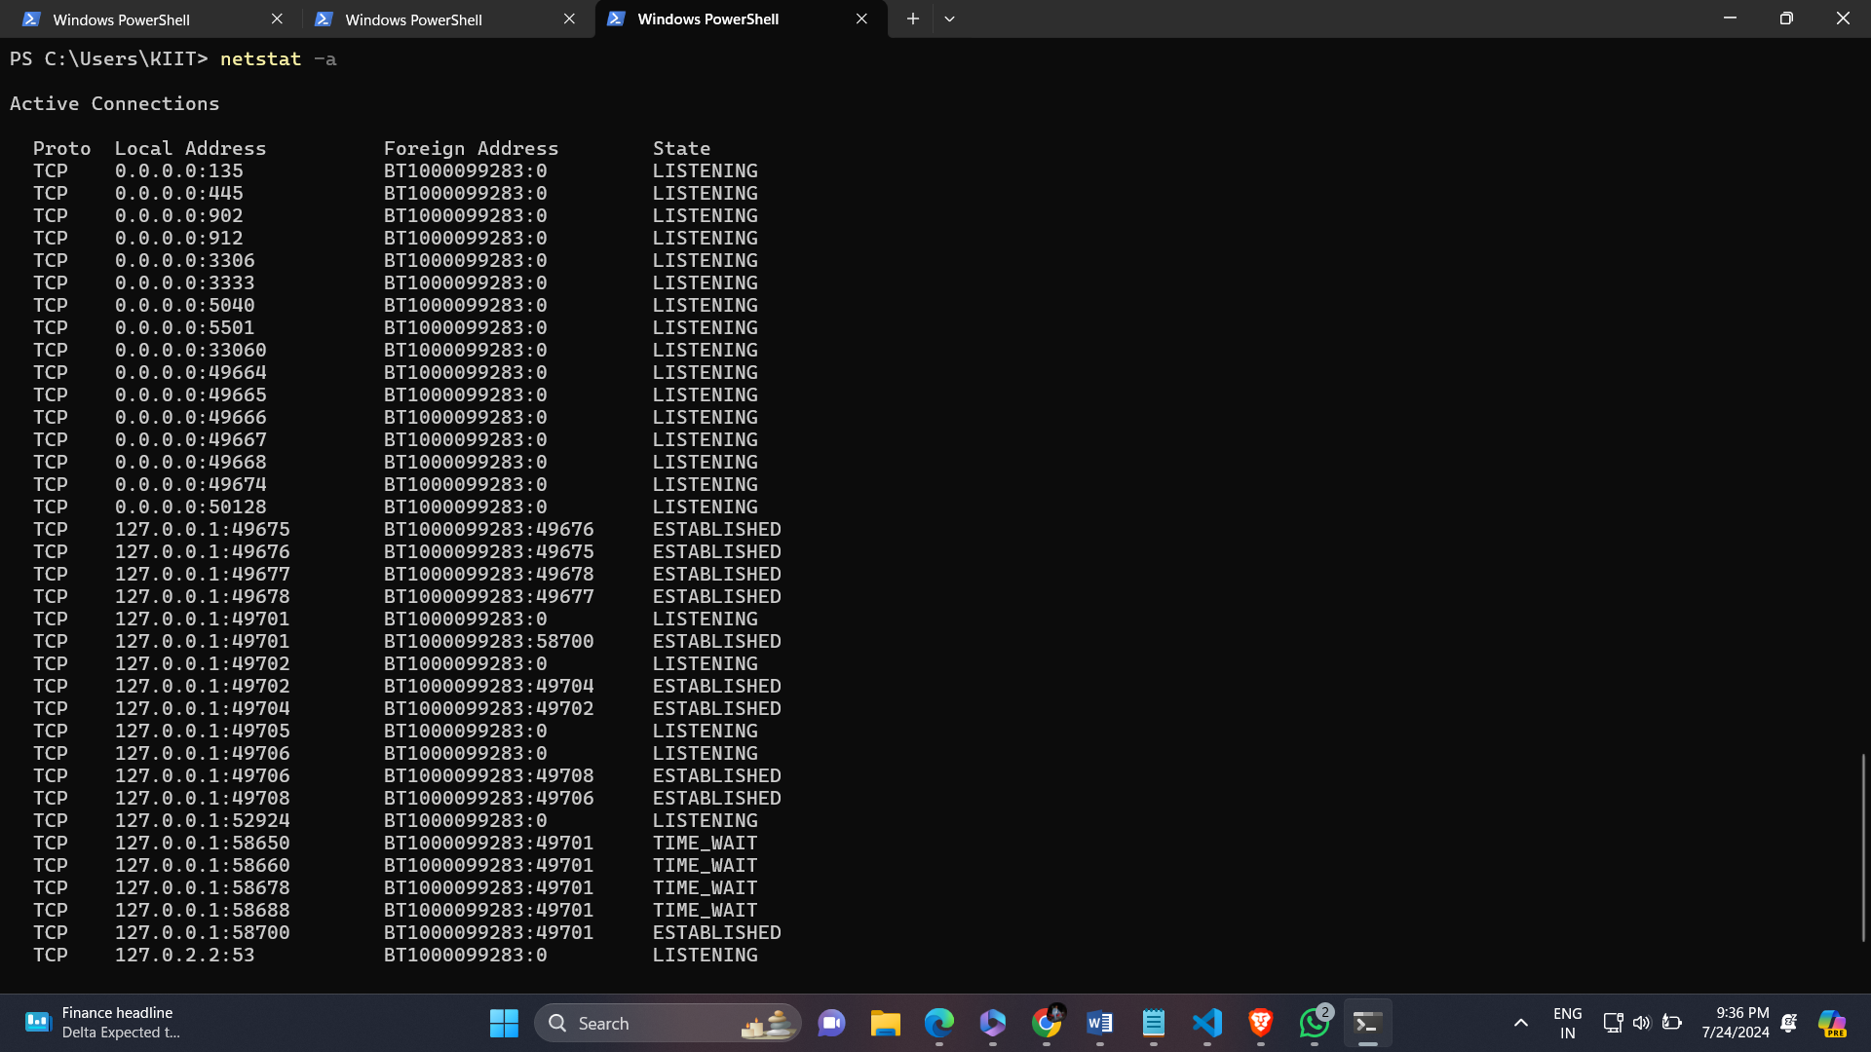

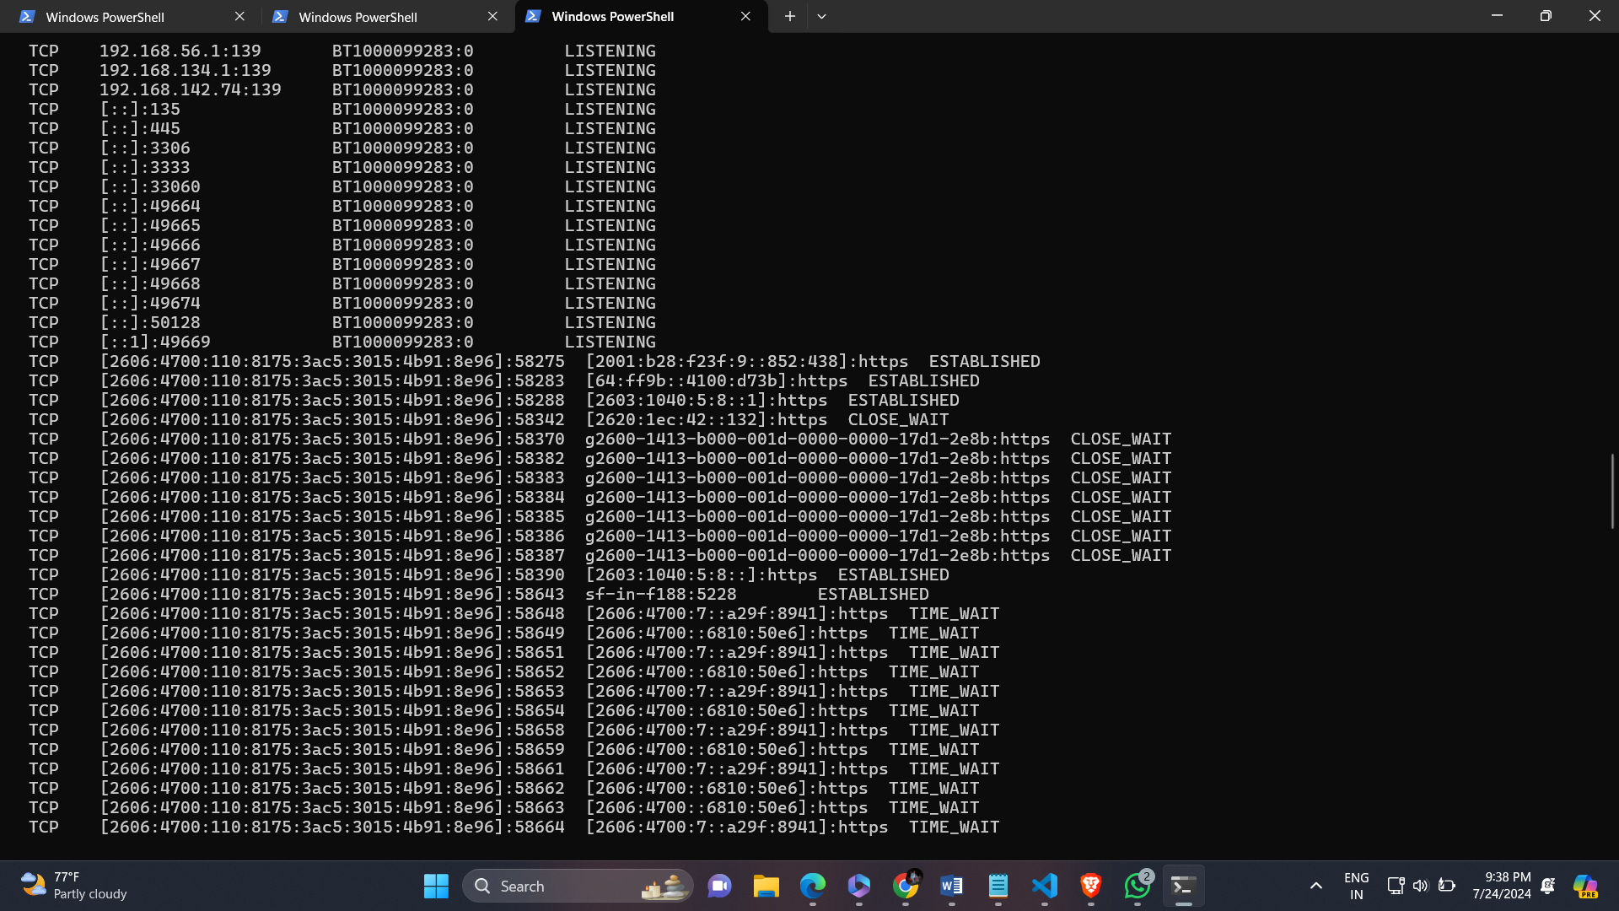



Netstat –e

It display Interface Statistics , including the number of bytes, unicast packets, non-unicost packets, discards, errors sent and received over the network interfaces.

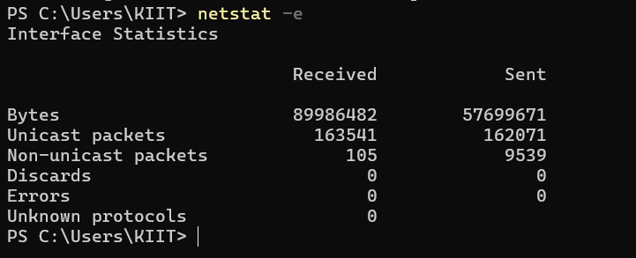

Netstat –n

It displays network connections and listening ports using numerical IP addresses and port numbers , rather than resolving hostnames.

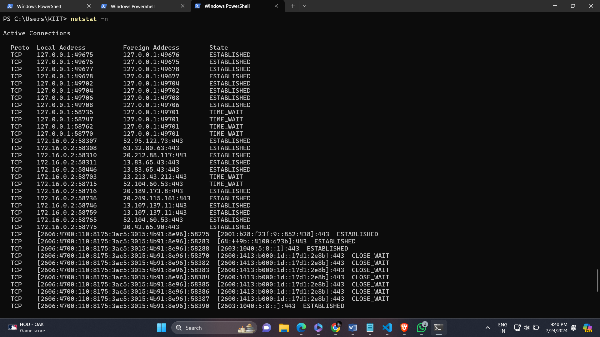

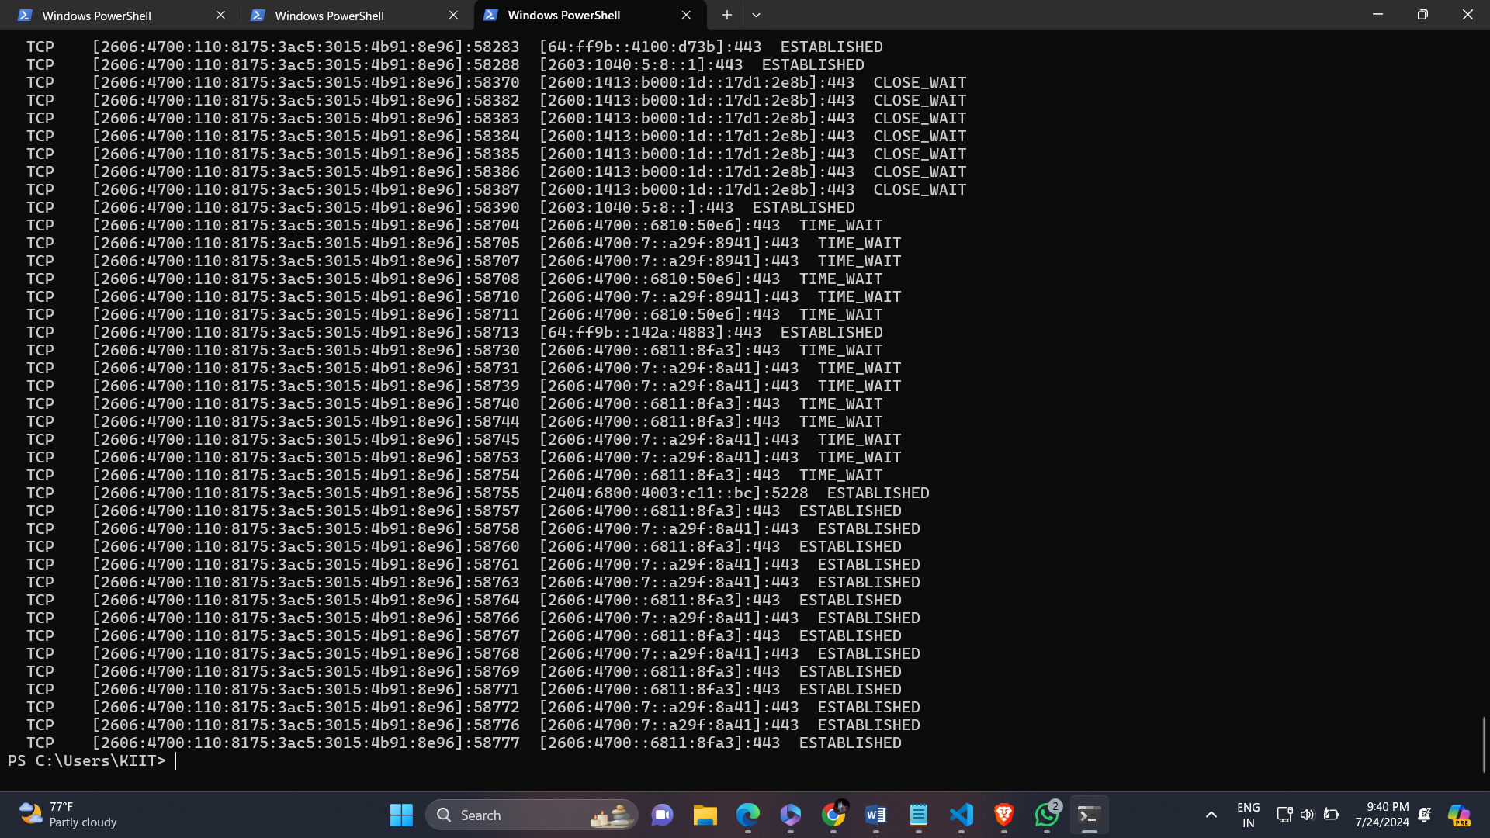

Netstat –o

It shows active active network connections along with process ID associated with each connection , helping identify which processes are using network resources.

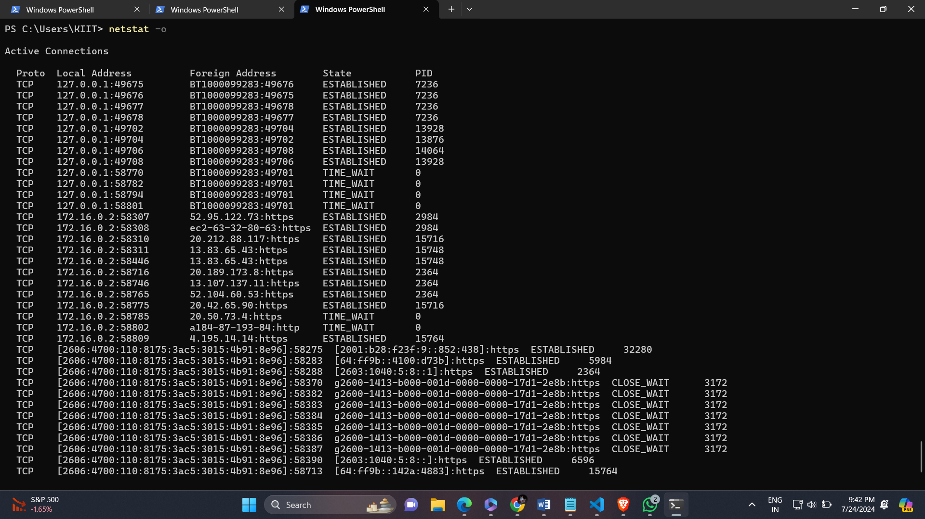

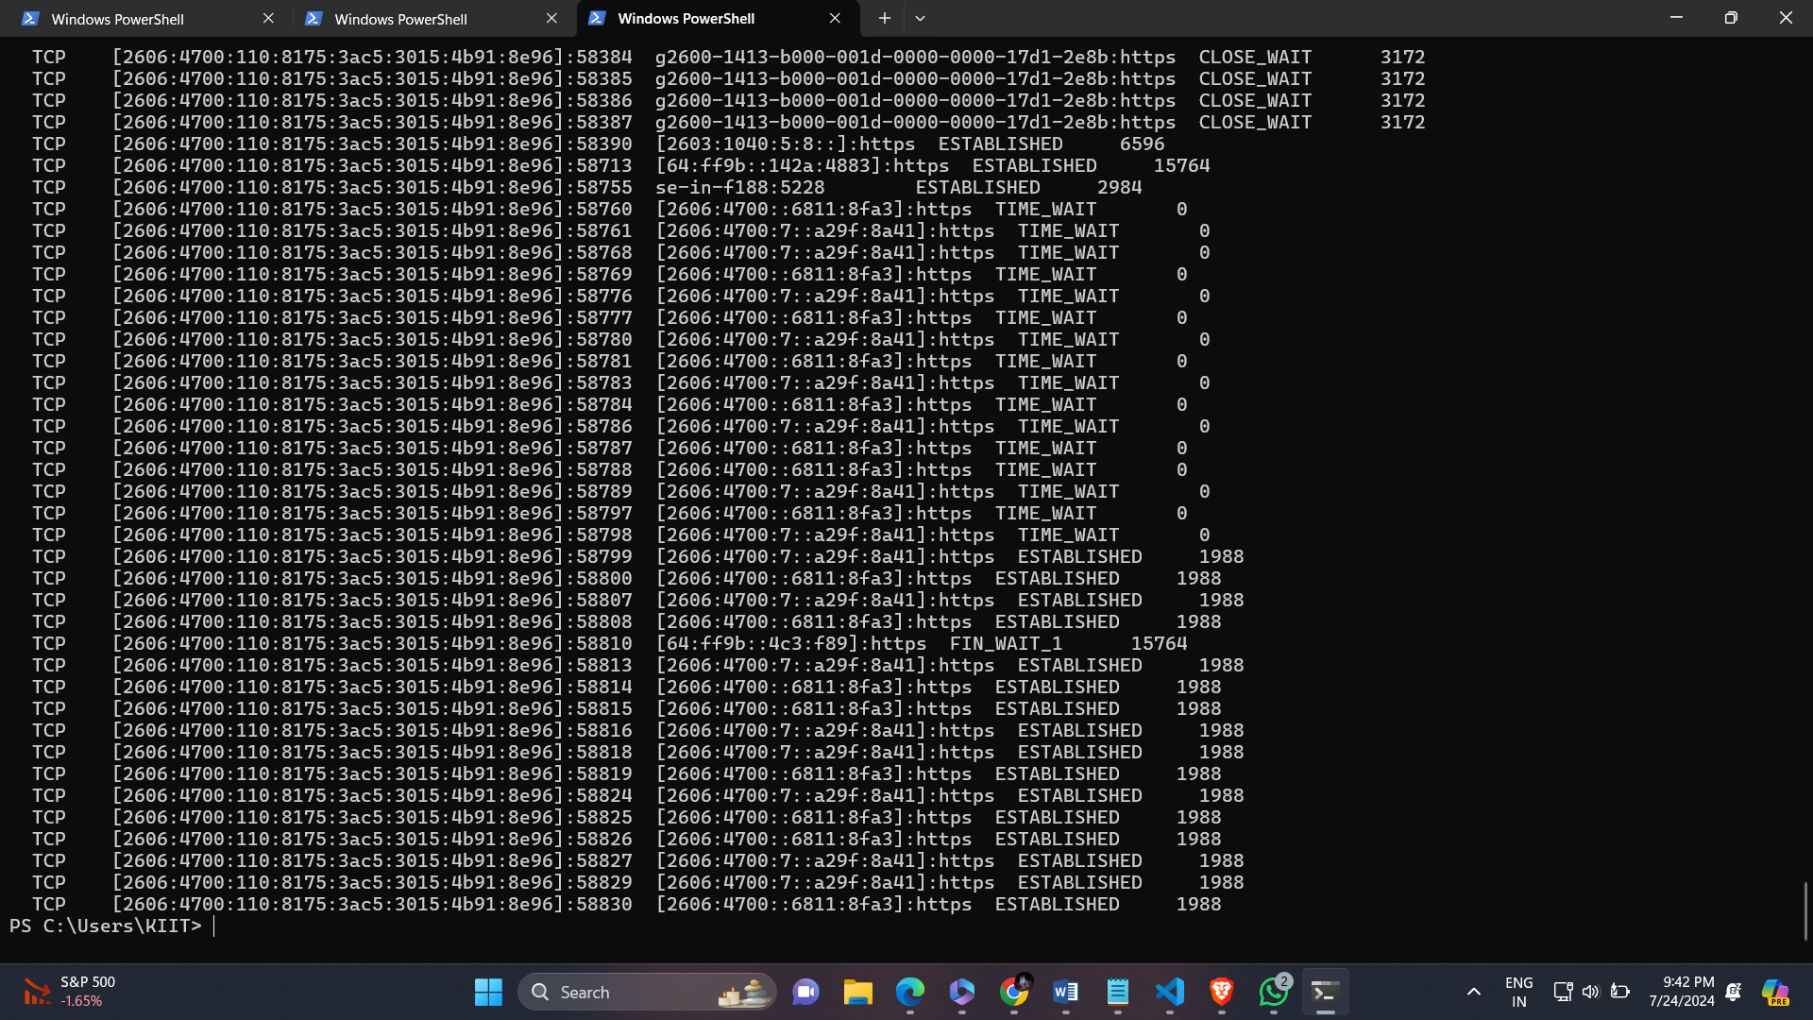

Netstat –p udp

It displays active UDP connections and listening ports, showing the process ID and the corresponding executable for each UDP connection.

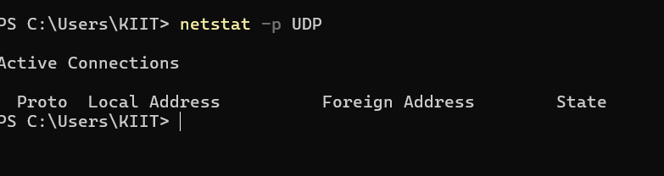

Netstat –s

It provides detailed statistics for each network protocol , including TCP,UDP and IP.

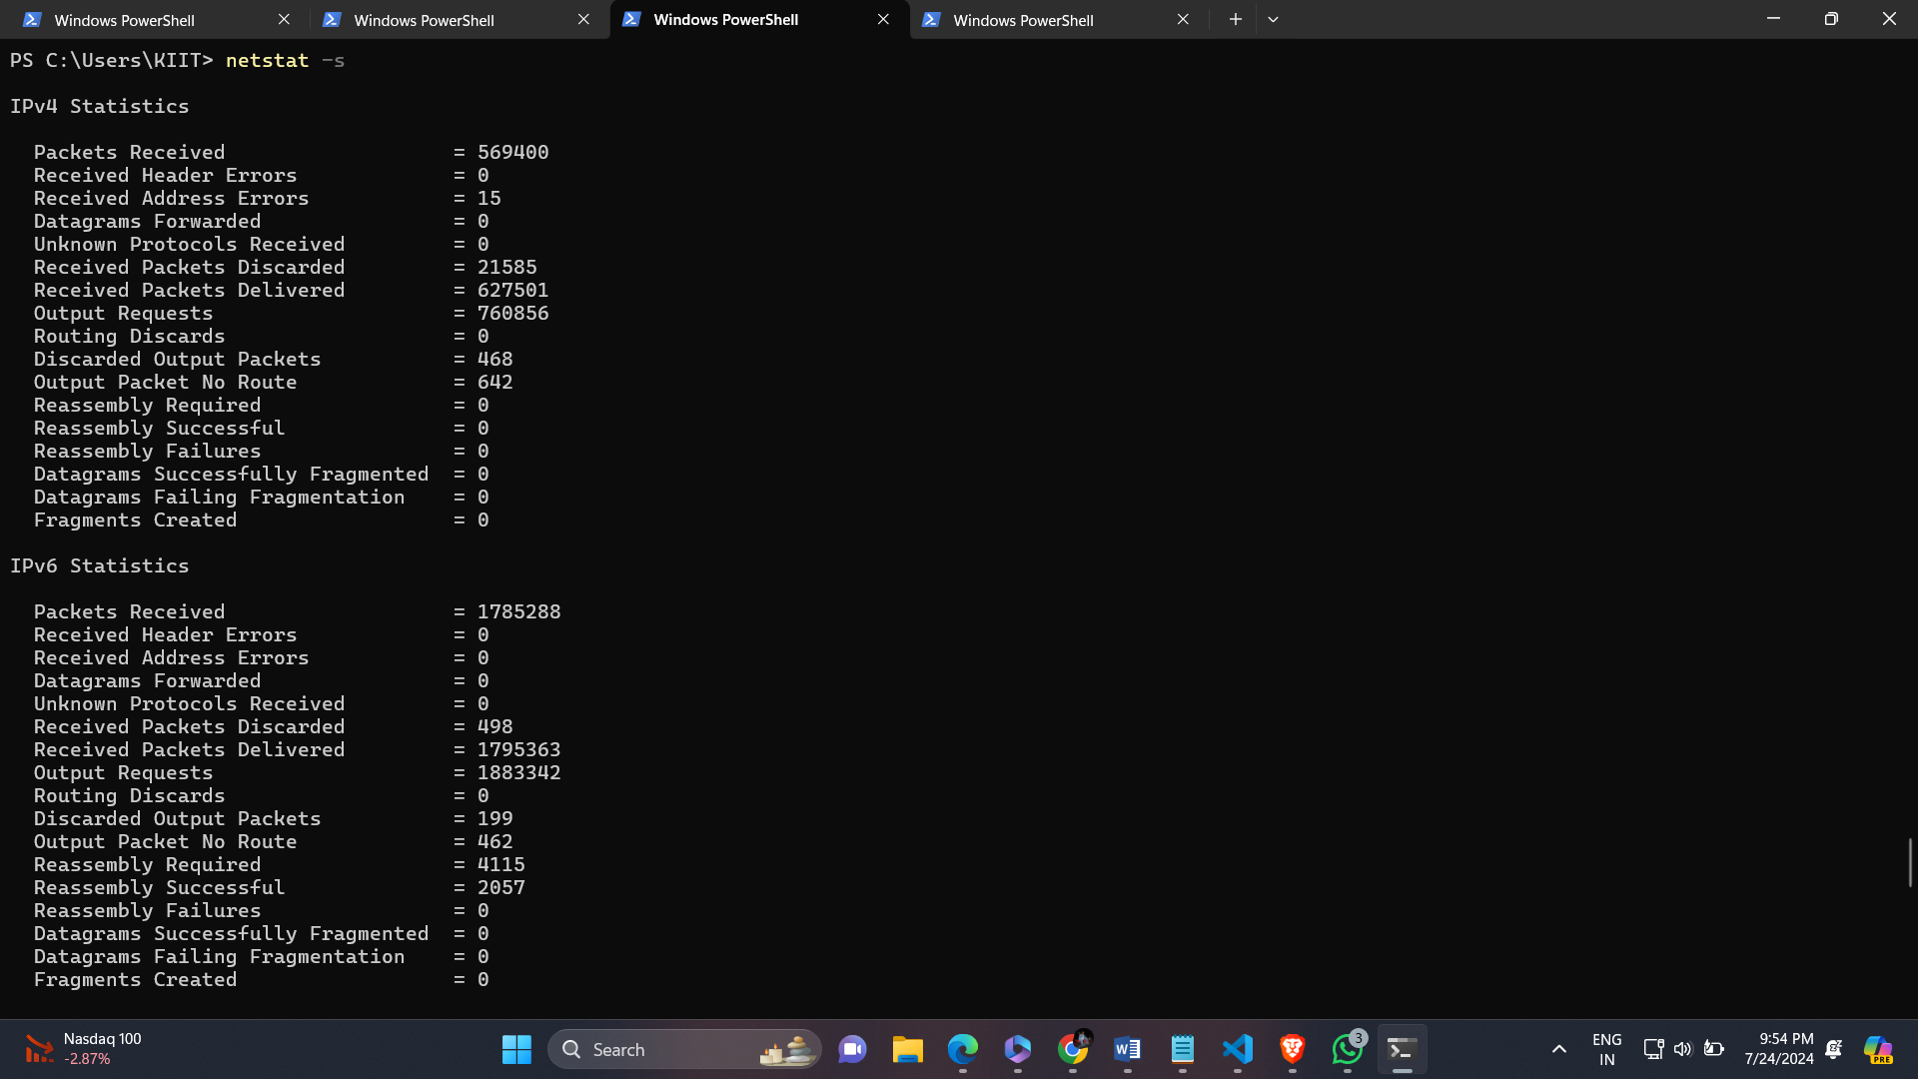

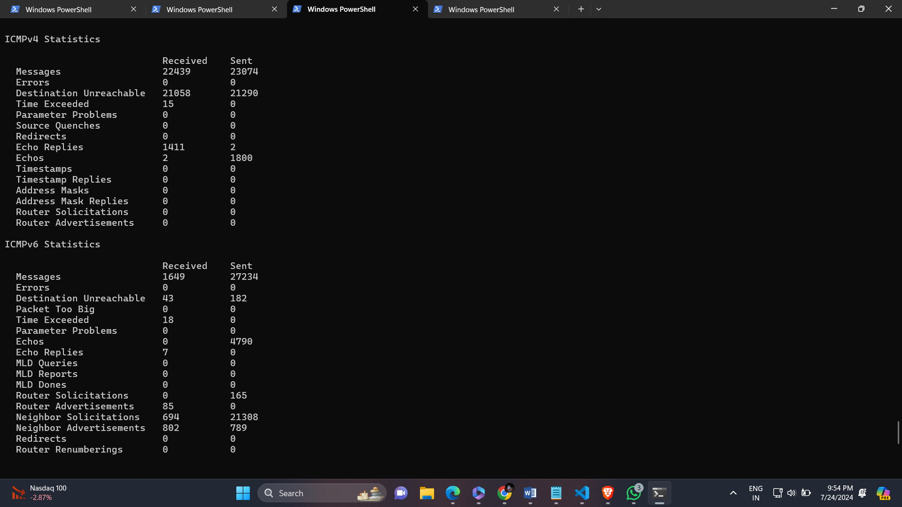

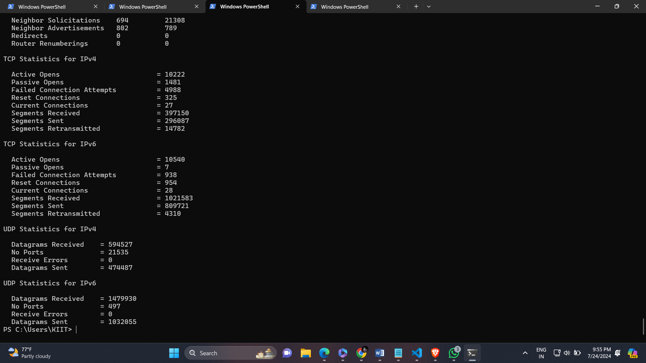

Netstat –r

It displays the routing table for your network, showing the network paths and destinations for packet forwarding.

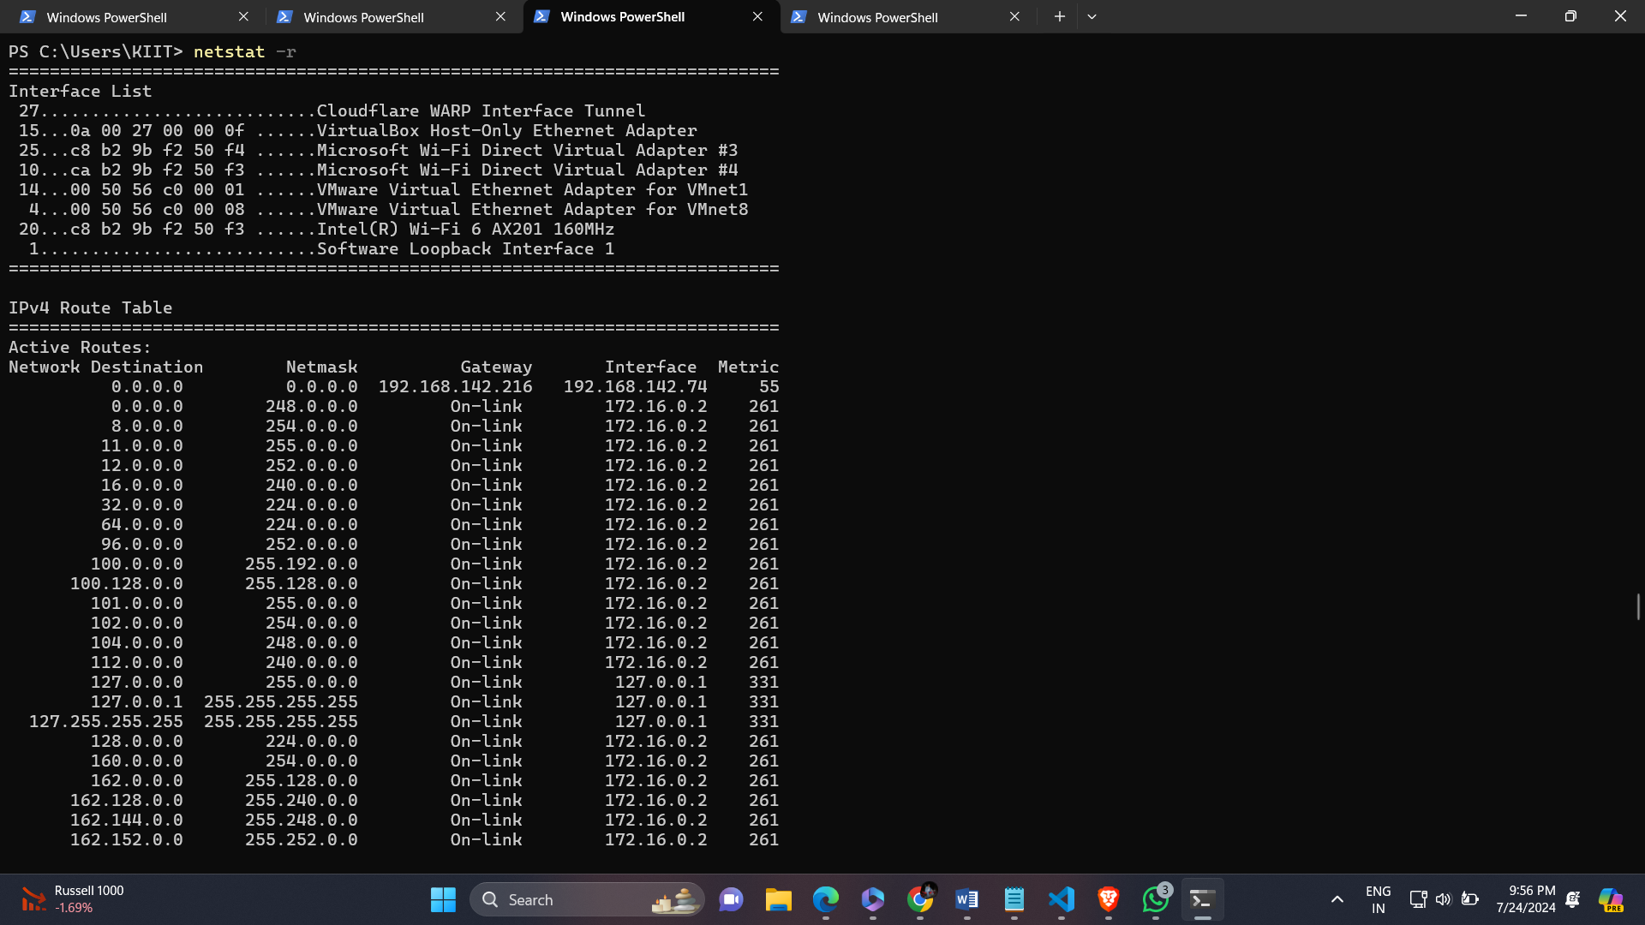



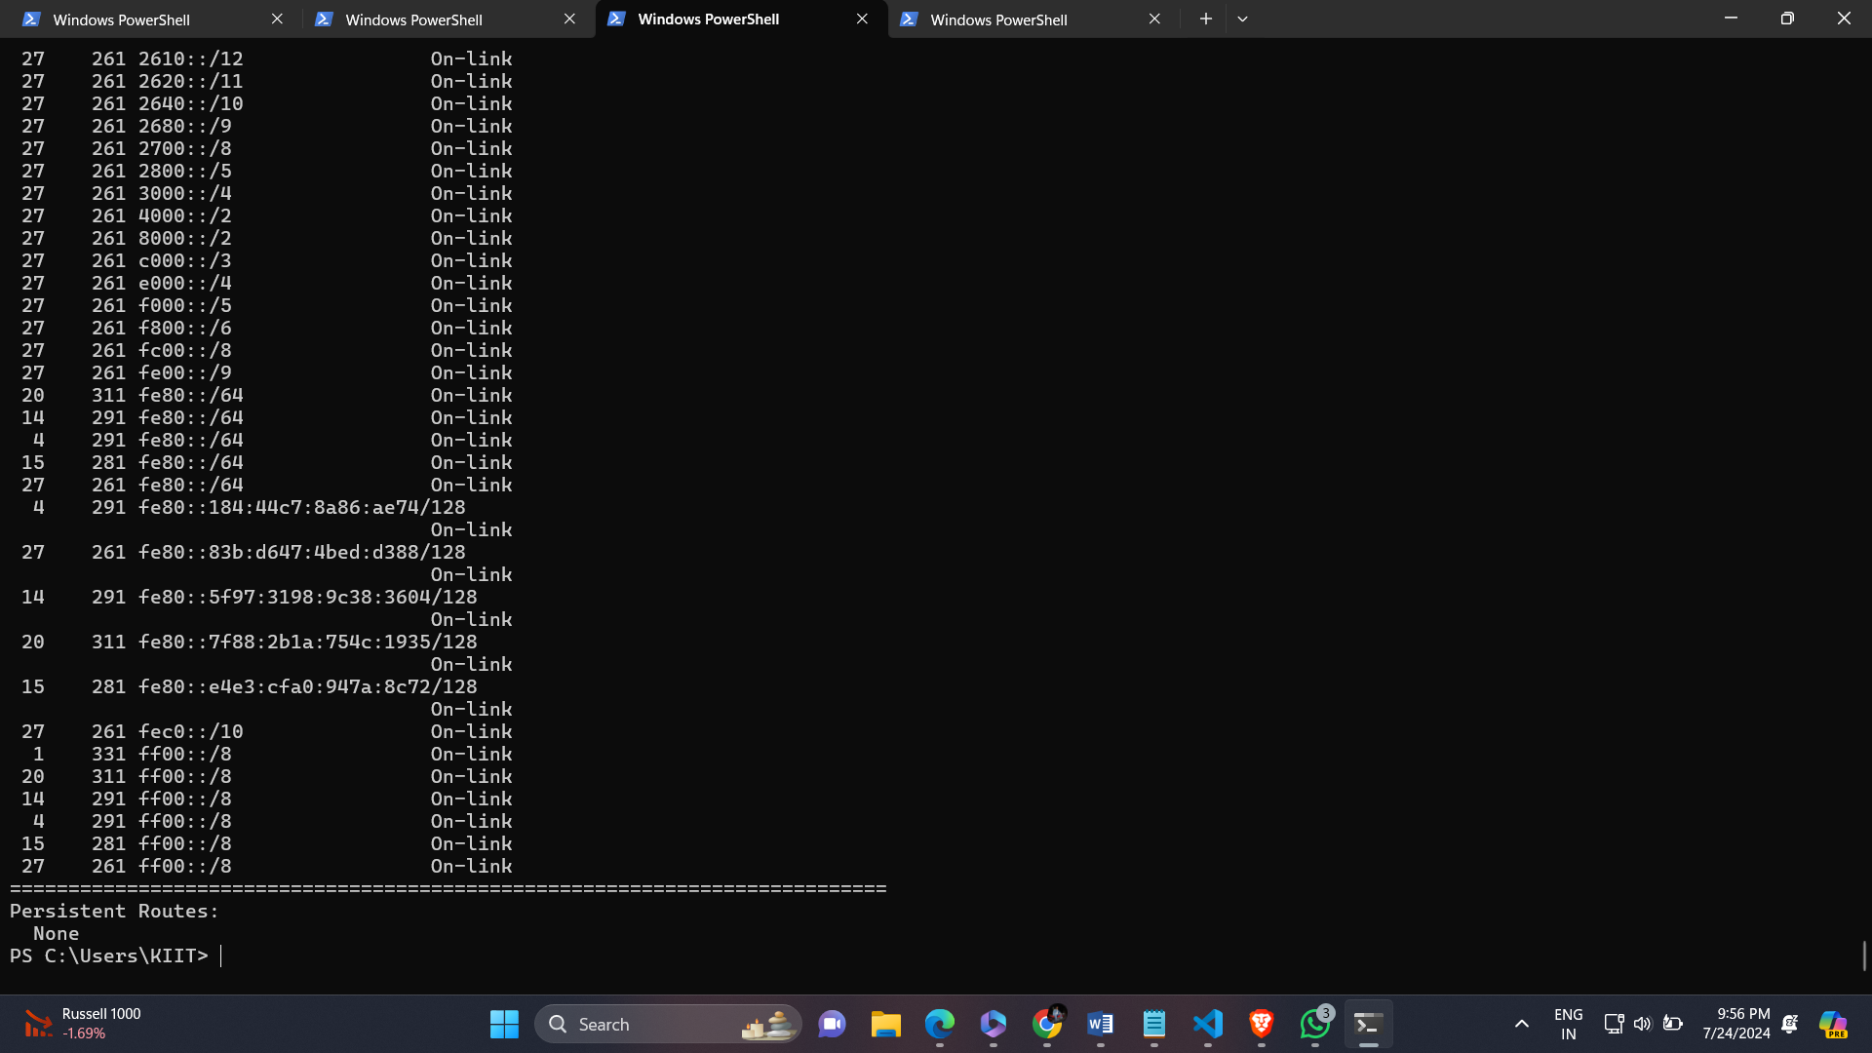

Netstat interval

It redisplays the selected information every interval seconds.

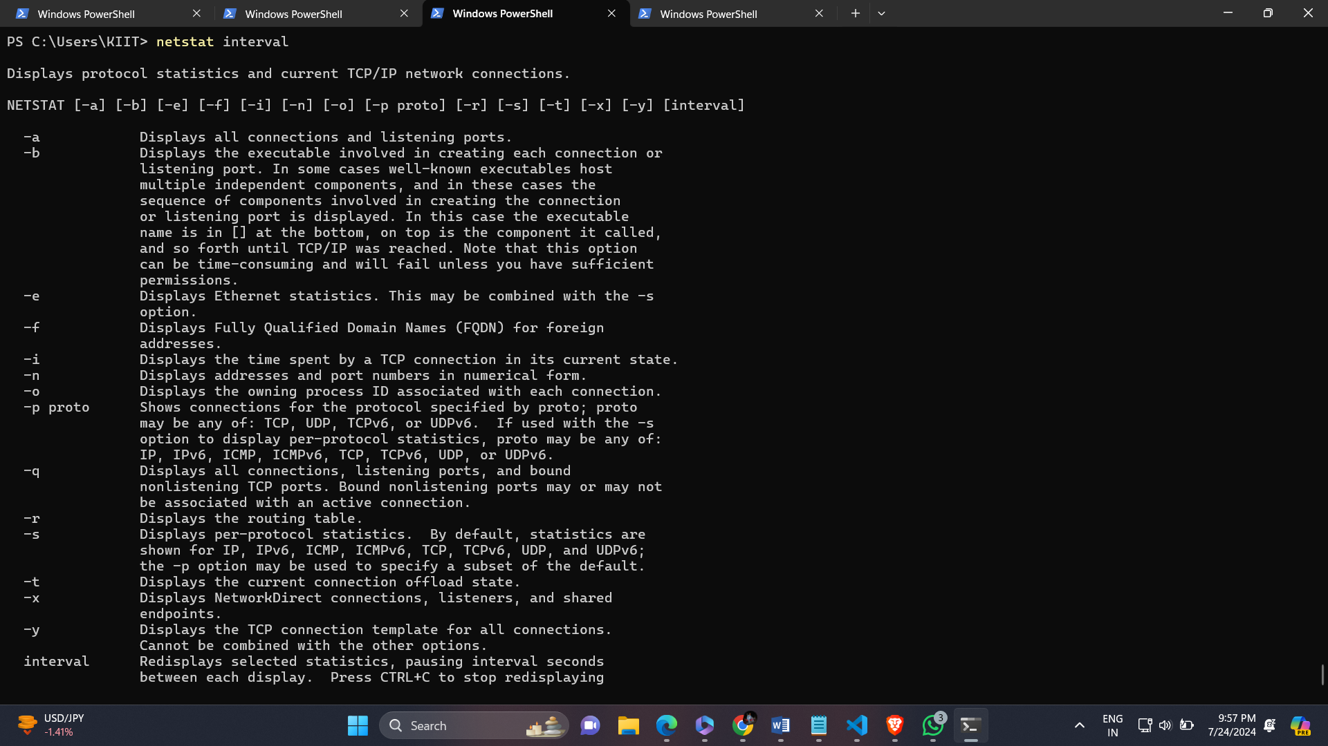

Netstat /?

It is used to display a list of all commands with their descriptions in “netstat”.

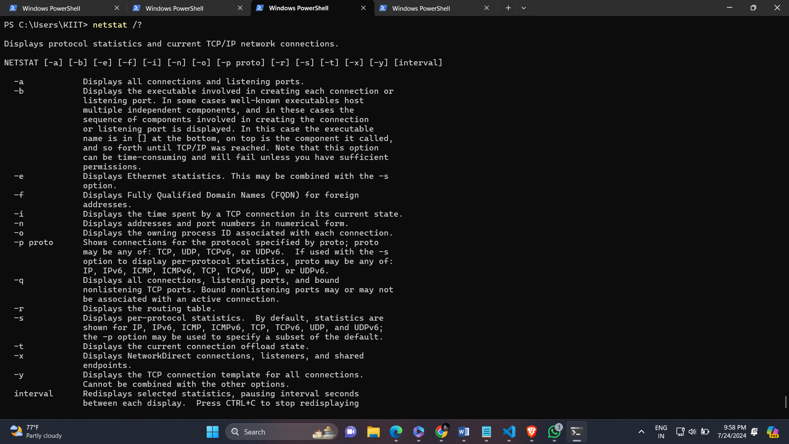

Arp –a

It is used for discovering the link layer address , such as a MAC address , associated with a given internet layer address , basically IPv4 address.

